(Approx. 1,269 words)

Photoshop Workflow Setups
A Review by John Donan, a Member of the North Orange County Computer Club, CA
www.noccc.org
editor(at)noccc.org

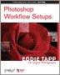

Obtained from APCUG with the author's permission for publication by APCUG member groups.


I knew I had seen that girl before when I found her on the frontispiece facing Chapter 1. There are also eleven other excellent full page images, some used in examples, five are facing the other chapters. I had seen the frontispiece on the Creativepro Website, under "Photoshop How-To: Tame the Beast,” (http://www.creativepro.com/story/howto/24366.html) which turns out to be Chapter 1 of the book which I also found at http://www.oreilly.com/catalog/photoworkflow/. I found these in my early research for the book. When I start a review, I browse for a cursory knowledge of a book's content then I research the author. I also find comments of other reviewers in case there is something I might overlook. Eddie Tapp, this author, is an award-winning photographer, lecturer, consultant, and author on digital imaging issues with over 20 years of experience in computer technology with a very impressive resume. From what Scott Kelby states on the cover, "If Eddie's teaching a session, I want to be there!" it implies that teaching is one of his strong points.

A statement preceding Chapter 1 says, "Adobe Photoshop has so many different work areas and tools that it can become confusing or even intimidating for digital photographers to use in a production environment. The fact is, there are only three particular zones or areas that you really need to become familiar with: tools, menus, and palettes.” Upon examining my version of PS CS2, I find 58 tools and 198 menu items which include the choices for the 19 palettes. Sixty of the menu items have further choices, as high as 20 or more in fly out menus as do all the palettes as well. Each of the tools has settings, relative to its function, which are made in its option bar. To place an order of magnitude on all this I assumed the number of secondary choices to be ten, it can easily be justified that there are over one thousand choices possible. You can add to this, keyboard shortcuts. There are 521 of them, I have counted. What can be done in Photoshop seems unlimited when multiple processes are involved. I created an effect using an adjustment and a filter; when I reversed their order the result was entirely different. Combine more than two such executions and the possible combinations and permutations grow tremendously. This is why the author says, "What is important is learning this information one step at a time, finding the option or settings that are important to your workflow and then building from there." This book intends to make this humongous set of choices manageable.

In 207 pages, the material covered had to be limited. Instead of picking apart a mass of nitty details the book provides guidance in overall effective usage. The book starts with efficient organization of the workspace. Anyone using Photoshop knows how quickly palettes hog the visible area (Tools and Options are palettes by the way). I cleaned up my work space by his example most of which is ignored in teachings elsewhere. This first chapter covered using a second window (see figure 1 which is typical of the illustrations of the book) and also tiling images, neither of which I had done previously nor had I ever considered the 9 settings possible for the status bar, via its black triangle. The rest of the first chapter concerns the Bridge.

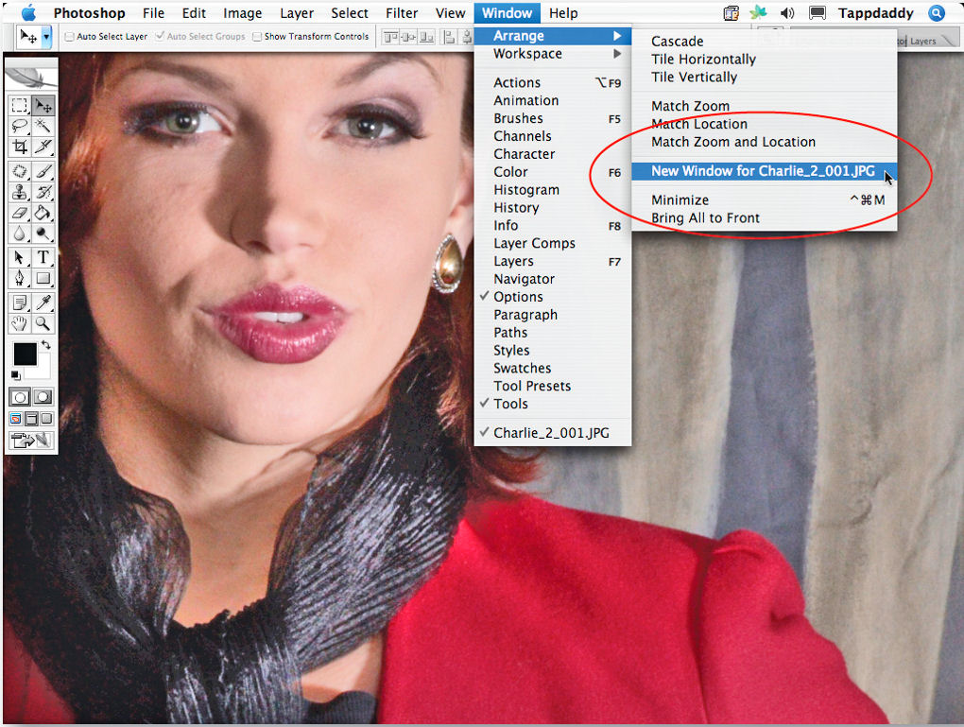

Figure 1, Photoshop opens a second window of your active image when you select Window > Arrange > New Window. It's perfect when you want to do detail work and see the entire image at the same time.

About 20% of the book concerns the Bridge, Photoshop's file browser. I had read where another Photoshop author refuses to use the Bridge because he feels it is yet too early in its state of development. This appears to be the case with my software for it will not open either Photoshop or JPEG images in Photoshop a feature of its main usefulness. To correct this will be expensive. Adobe technical support has told me that they require an advance payment of $39 to address either of these problems ($78). For those who are able to properly use the Bridge, or willing to pay to make it work, it is covered in Chapter 5 of the book.

All palettes are covered and should one want to get a quick handle on a palette you don't use, such as Layer Comps, the information is there. Although the information for this palette is held to one page, it is adequate enough for me to have now mastered its use. The key palettes are stated to be these: Layers, Channels, Actions, History, Histogram, Color, Styles, Paths and the Info window. To unclutter his workspace, Tapp places his most active palettes in the Docking Well, cycling them as he needs them. By saving this configuration, it is always available as a starting workspace at some future time. One of his notes in this part of the book introduced me to the Scrubby Slider. It has been in existence since CS. When the mouse cursor is in the vicinity of a slider label, it changes allowing the slider value to be changed without having to grab the slider exactly.

Preferences allow you to tailor your work to your needs. Of course some are more important than others. Chapter three considers those the author has found to be most important. As with other Adobe programs, the Preferences dialog box can be accessed via Ctrl-K. Nine dialogs are selectable. A point came up regarding image interpolation and the General Preferences dialog which is not widely known. For Image Interpolation: Bicubic Smoother is designed for up-sampling images, while the Bicubic Sharper is designed for down sampling images. Compared to some of my 600 page books, there is twice as much information on preferences in this little guy.

The chapter "Customizing Keyboard Shortcuts and Menus" is brief (12 pages) but handy, should one want to specialize either of these for personal use. An adjustment, which I regularly use, is Shadow/Highlight. It is also frequently used by the author. He has assigned for it the shortcut Shift+Ctrl+M which I have now also done, thanks to this chapter. Should I lapse into my old ways and traverse Edit>Adjustments>Shadow/Highlight the selection is handily highlighted in red (my choice.)

In the preface for the last chapter (Tapping into the Tools), the author states: "What is your favorite tool in Photoshop? Most people will say without reservation, the Clone Stamp tool. Yes, it's a very powerful tool indeed, but the Clone Stamp tool can also be the most dangerous if it’s not used properly." What he is referring to is repetitive patterns which aren't seen until after the image is printed. In slightly less than a page the use of this tool is completely covered. In fact this concise coverage brought home to me two features I had overlooked using.

I will continue using this book as a handy reference as can others whose PS skills may vary anywhere from beginner on. The book details are:

Title: Photoshop Workflow Setups
Subtitle: Eddie Tapp on Digital Photography
First Edition: August 2006
ISBN: 0-596-10168-6
Pages: 207
MSRP=$30.
The book is available from O’Reilly at a discount of 35% to user group members.

This article has been provided to APCUG by the author solely for publication by APCUG member groups. All other uses require the permission of the author (see e-mail address above).

